Hispanic Heritage Month – Nuestra gente

Table of Contents

Overview 1
Employer Outreach Instructions 2
Employer Outreach Email 3
Drop-in Article 4
E-Newsletter Copy 6
Social Media Copy and Images 10
Posters 10

Overview

National Hispanic Heritage Month takes place from September 15 to October 15 and is a chance to recognize and celebrate the contributions of Hispanic and Latino communities. It’s an opportunity to encourage Hispanic and Latino audiences, many of whom are at higher risk for type 2 diabetes, to make their health a priority.

Here are some facts:
According to CDC, the percentage of Hispanic or Latino adults in the U.S. living with diabetes by country of origin were:
- 25% for Mexicans
- 22% for Puerto Ricans
- 21% for Cuban/Dominicans
- 19% for Central Americans
- 12% for South Americans

- 35% of Hispanic or Latino adults have prediabetes.
- 50% of Hispanic or Latino people are expected to develop type 2 diabetes, which is 10% higher than the general population.

Learn more by reading the Hispanic and Latino Audience Profile found on the 1705 SharePoint site. The resources provided in this bundle can help serve as a base to incorporate encouraging, culturally appropriate messages and imagery into your promotions to further strengthen the connection of your program to Hispanic and Latino communities.

This year’s National Hispanic Heritage Month content includes messaging with the theme nuestra gente, which translates to “our people.” The connotation of this phrase is one of pride in cultural heritage and identity, as well as a strong tie to community, and is used in everyday conversation. The phrase can reference family, friends, community, and culture with positivity and pride. The idea of community as a motivation for healthier living and support for a health journey is the inspiration for this campaign.

Each week of the month includes tailored content focused on an aspect of Hispanic or Latino culture and how healthy living fits into cultural traditions. These weekly themes are:
- Family/Community
- Food
- Music/Dance
- Celebration

This bundle also features standard promotional content for your own organization’s Hispanic Heritage Month communications:

- 2 Drop-In Articles. It is recommended you place these in a newsletter, local newspaper/magazine, and/or your organization’s website. There is one for the beginning of the month and one for the end of the month to frame your Hispanic Heritage Month campaign.
- 4 E-newsletter Drafts. This copy can be used for email newsletters or listservs you may have. There is one email for each week of the month for the specific weekly theme that includes related health tips.
- 8 Social Media Graphics and Post Copy. There are 8 social media graphics and associated post copy for use throughout the month. Graphics and posts are organized to correspond to the weekly themes.
- 3 Posters. These posters have been designed for placement in employer settings, doctors’ offices/health care settings, and community health organizations, respectively. The goal of these posters is to draw attention to the risk of prediabetes and encourage people to learn more about and enroll in the lifestyle change program.

To engage the broader community, information is included on reaching out to employers and inviting them to participate in Hispanic Heritage Month promotions of the lifestyle change program. There are instructions and an outreach email template for use in engaging employers.

Employer Outreach Instructions

Diabetes affects the health of employees and a company’s bottom line. Diabetes negatively affects workers’ health and well-being, which in turn can make them less productive in the workplace and lead to more time off work and increased health care costs for employees and employers. Because of this, it is important to engage employers as partners in your work to promote the National Diabetes Prevention Program lifestyle change program.

During National Hispanic Heritage Month (September 15 – October 15), many people and organizations in the United States take the opportunity to recognize and celebrate the contributions of Hispanic and Latino communities. This observance is an opportunity for you to engage employers to encourage Hispanic and Latino audiences to make their health a priority.

First, you will need to identify employers to partner with for this campaign. Consider not only office-based employers, but also ones such as manufacturing, agriculture, and construction, depending on the industries common to your area and demographics of your Hispanic and/or Latino population. You should also include any employers you already have a relationship with or have reached out to in the past.

The employer outreach email template will help you to connect with organizations in your area, introduce the lifestyle change program, and engage their help in your promotional efforts. When you contact employers, you can share the Hispanic Heritage Month Toolkit for Employers, which includes materials designed specifically for employers to promote the lifestyle change program.

There is e-newsletter content, social media images and posts, and posters that have been tailored to a workplace setting. Customize these templates with the name of your organization and lifestyle change program name and website before sharing with employers.

The Key Messages and Talking Points Job Aid, available in both English and Spanish, is also a useful resource for messaging about prediabetes, type 2 diabetes, and the lifestyle change program as you engage with employers.

Employer Outreach Email

To use: The following e-newsletter copy can be used for outreach to local employers and organizations to engage them in your Hispanic Heritage Month efforts to promote the lifestyle change program.

Dear [insert name of organization or contact],
My name is [insert name], and I work with [insert your organization’s name]. We offer [insert name of your program], a lifestyle change program focused on preventing type 2 diabetes, which is part of the National Diabetes Prevention Program led by the Centers for Disease Control and Prevention (CDC).
It is estimated that 88 million US adults have prediabetes, which means they have blood sugar levels that are higher than normal and are at risk for developing type 2 diabetes. It is likely that 1 in 3 of your [insert number of employees] employees already has prediabetes. For the Hispanic and/or Latino population, the risks are even higher, with 50% of adults in this group expected to develop type 2 diabetes, which is 10% higher than the general population.
Diabetes is a costly condition and increases people’s risk of disability and other illnesses. This means your employees are more likely to miss work if they have type 2 diabetes, and the costs of health care for diabetes can lower your bottom line. As an employer, you care about your employees and how they’re doing, and you also want to ensure your organization remains efficient and successful.
Because of this, [insert your organization name] is encouraging Hispanic and Latino people to learn about their risk for prediabetes and enroll in the lifestyle change program this Hispanic Heritage Month. The observance runs from September 15 through October 15 and is a chance for your organization to join us and celebrate the contributions of your Hispanic and/or Latino employees.
As part of your efforts for Hispanic Heritage Month, we invite you to share some promotional information about the lifestyle change program and support your employees in learning how to get healthier and prevent type 2 diabetes.
I am attaching a Hispanic Heritage Month Toolkit for Employers, available in English and Spanish, to assist you in educating your employees about their risk of type 2 diabetes and how [name of your program] could help them live healthier lives. We encourage you to use the materials by sending the e-newsletter copy in internal communications, displaying the posters in your office, and/or posting the social media content on your organization’s platforms.
If you have any questions, please call or email me at the contact information below. I can provide more details about prediabetes and the lifestyle change program to support you and encourage your employees to enroll today.
Sincerely,
[insert name, title, and organization]
[insert email address and phone number]

Drop-in Article

To use: You can post the following two articles to your organization’s website, publish in your organization’s newsletter, and/or send to a local newspaper or magazine. You can also download an image to use with the articles from the 1705 SharePoint site.

Week 1 – The first week of Hispanic Heritage Month, you can use the following article to introduce the theme of your campaign and promote the value of community and family.

Nuestra Gente: The Reason for a Healthier Tomorrow

The contributions of Hispanic and Latino people have been so important to the success of our nation. Hispanic Heritage Month is a chance for [name of organization] to celebrate your community, strength, and resiliency during troubling times. While the accomplishments and strengths of Hispanic and Latino communities are not limited to one month a year, this is a chance to spotlight nuestra gente.

This has been a tough year and a half, but through the hard times, nuestra gente has shown resiliency, strength, and hope. Through the COVID-19 public health emergency, we have learned the importance of personal health and community support in making healthy choices. Family and community are stronger when each individual takes care of themselves and their health. We’re in this together to live healthier all year long, and [name of organization] is here to help.

Many people struggle to manage their health. According to the Centers for Disease Control and Prevention (CDC), 88 million US adults have a condition called prediabetes, meaning they have higher blood sugar levels than normal, but not yet high enough to be diagnosed as type 2 diabetes. But did you know that for Hispanic or Latino adults, the number of diagnoses is higher than for other groups? For Hispanic or Latino adults, 35% have prediabetes, and 50% are expected to develop type 2 diabetes, which is 10% higher than average.

Having good health impacts all you do – and those around you. Type 2 diabetes can put limits on family and community activities and the time you get to spend together. Our theme for this Hispanic Heritage Month is nuestra gente, recognizing the importance your loved ones have in your life and on your health. You’ve made sacrifices for your family and community—now it’s time to take care of yourself so you can keep taking care of those you love. Let [name of organization] help you to prevent type 2 diabetes so you can be around longer for those you love.

We know it can be hard to take time for your own health – it might even feel selfish – but when it seems like it’s not worth the effort, remember that building a healthier future for yourself sets an example for coming generations. This helps ensure that type 2 diabetes is not a part of your family legacy, getting in the way of the wonderful traditions you enjoy most. You can learn about your risk for prediabetes by taking the CDC’s Prediabetes Risk Test.

CDC’s National Diabetes Prevention Program (National DPP) is here to help adults with prediabetes learn to prevent or delay type 2 diabetes. We offer the National DPP lifestyle change program, which focuses on eating healthier foods, getting more physical activity, and managing stress to lower the risk for type 2 diabetes and for better health overall.

The lifestyle change program is built around group sessions because you don’t have to take this journey alone. With the support of your peers and trained Lifestyle Coaches, you’ll find the habits that work for you and your family and still allow you to enjoy beloved foods and traditions.

[Customize this section with your own quote from a Hispanic or Latino coach or use the following language: Lifestyle Coach Elvia Alcala says the program is designed to help you make small yet lasting changes. “As Hispanics, we are used to eating chicken, rice, beans, fries, and tortillas, and in many cases we don’t include vegetables, salads, and fruits. That’s why one of our goals with the program is to help participants see that if they make changes in what they eat, their health will improve and they will live better. Small changes can make a big difference.”

With coaches like Elvia, [name of organization]’s program is here to help you get healthier. We offer programs [details on class offerings such as time, location, Spanish-speaking, virtual, etc.]. The tips you learn will not only improve your health but can also be an opportunity for your whole family to get healthier together. Involving those you love will give you the motivation to get going, knowing that you’re doing this for your people and with your people.]

So what’s left to stop you? Don’t let type 2 diabetes define your future when you have so many worthwhile things to live for. Preventing health problems is important to ensure that you can keep on accomplishing your goals and leaving an even greater legacy for the future.

Week 4 – The fourth week of Hispanic Heritage Month, you can use the following article to wrap up your campaign and feature a celebration of Hispanic/Latino culture.

Celebrating Success this Hispanic Heritage Month

There is so much you already do for your family, community, and country, and that’s worth celebrating throughout the year. Choosing to get healthier and making time to prioritize your health is part of that celebration! Healthy changes can support a happier life and more time with the people you care about the most. [Name of organization] is here to help you prevent or delay your risk for type 2 diabetes, because there’s no need for health problems from diabetes to slow you down.

The Centers for Disease Control and Prevention (CDC) says that compared to other groups, Hispanic and Latino adults are at higher risk for developing prediabetes and type 2 diabetes. Don’t let diabetes be a tradition you pass on in your family! The decisions you make today to get healthier can impact those you care about for generations to come.

Learning how to eat healthier, get more physical activity, and manage stress may sound intimidating on top of everything else you do caring for your community and family and other responsibilities. But this isn’t a journey you have to take alone.

CDC’s National Diabetes Prevention Program (National DPP) offers a group-based lifestyle change program designed to help you reach your health goals and prevent or delay type 2 diabetes. We want to highlight ways the program helps you to stay healthy and supported in challenging times. We know it’s not always easy but creating a healthier life for you and your family is a great way to celebrate yourself for all you do for others.

Here are some top tips from the National DPP lifestyle change program to help you make healthy changes today.

Do it with your friends and family. Getting healthy on your own can be a challenge! Set goals with your family, friends, or neighbors to motivate each other. Consider making healthy meals for your family to eat together or going for a walk with a neighbor for some physical activity.

Add more vegetables and fruits to your diet. We know many have beloved dishes which include rice, tortillas, fried ingredients, or other fats and carbs. These delicious foods should be enjoyed in moderation by keeping the portion sizes smaller. This leaves room to add fresh fruits and vegetables to your meals. Even this small change can have a big impact on your health.

Play some music and get dancing. Putting on music to dance at home or at social events is a great way to get in some healthy physical activity. Consider playing music throughout the day or as you go about household tasks to encourage you to get up and get moving. It’s an easy way to be more active in your day.

Celebrate reaching your health goals. You already have a lot to be proud of, and choosing to start healthy habits is just as important as your many other accomplishments. By making time for your health, you can create a better future for yourself and those you love. If you’ve put in the work to begin your health journey, take some time to celebrate your success!

Though Hispanic Heritage Month may be coming to an end, we know that the work isn’t over. Getting healthy is a lifetime journey. [Name of organization]’s program works throughout the year to help you make lasting changes so that preventing type 2 diabetes becomes a new legacy for your family.

E-Newsletter Copy

To use: The following e-newsletter copy can be used to promote the program in online e-newsletters and email blasts. Consider placements in a community newsletter, local health care provider or network newsletter, and/or faith-based newsletter.

Week 1 – The first week of Hispanic Heritage Month, you can use the following e-newsletter copy to introduce the theme of your campaign and promote the value of community and family.

Subject: Nuestra Gente: The Reason for a Healthier Tomorrow

The contributions of Hispanic and Latino communities have been so important to the success of our nation. Hispanic Heritage Month is a chance for [name of organization] to celebrate community, the strength of your diverse cultures, and your resiliency during troubling times. While Hispanic and Latino accomplishments and strengths are not limited to one month a year, this is a month to spotlight nuestra gente.

[Name of organization] recognizes that the COVID-19 public health emergency has impacted many in the Hispanic or Latino community, requiring many sacrifices to keep those you love safe and healthy and at times bringing tremendous loss. That’s why our theme for this Hispanic Heritage Month is nuestra gente, recognizing the importance your loved ones have in your life. For all you do for them, we celebrate you and encourage you to take care of yourself too.

Many people face challenges with managing their health. According to the Centers for Disease Control and Prevention (CDC), 88 million US adults have prediabetes, meaning they have higher blood sugar levels than normal, but not yet high enough to be diagnosed as type 2 diabetes. Hispanic and Latino adults are at higher risk than other groups, making it important for you to live healthier now.

Here are a few ways you can prioritize your health this Hispanic Heritage Month:
- Learn about your risk for prediabetes by taking the CDC’s Prediabetes Risk Test. It only takes a minute!
- Join CDC’s National Diabetes Prevention Program lifestyle change program. It can help you make healthy changes to prevent or delay type 2 diabetes, including eating favorite foods in healthier ways, getting more physical activity, and managing stress for better health.
- Make some health goals with your family and friends. This could mean adding more fruits and vegetables to meals or getting outside together for a walk.
- Don’t be afraid to reach out for help. It can be difficult to learn how to live healthier on your own! That’s why the lifestyle change program has group sessions with your peers led by trained Lifestyle Coaches to support you in your journey.

We offer the lifestyle change program [details on class offerings such as time, location, Spanish-speaking, virtual, etc.] to help you prevent type 2 diabetes and support better health. You can involve those you love to motivate you, knowing that you are doing this for your people and with your people. So what’s left to stop you? Preventing health problems today ensures you can leave an even greater legacy for the future.

Week 2 – The second week of Hispanic Heritage Month, you can use the following e-newsletter copy to promote healthier eating and provide nutrition tips from the LCP to Hispanic/Latino families.

Subject: Dinner Is Served – Eating Healthier To Prevent Diabetes

According to the Centers for Disease Control and Prevention (CDC), Hispanic and Latino adults are at higher risk for prediabetes, meaning their blood sugar levels are higher than normal, but not high enough yet for a diagnosis of type 2 diabetes. If you have prediabetes, you are at increased risk to develop type 2 diabetes unless you make some changes to your lifestyle. Because of this, we want to provide some tips to help you live healthier.

CDC’s National Diabetes Prevention Program offers a lifestyle change program designed to help you prevent or delay type 2 diabetes. [Name of organization] offers the lifestyle change program [details on class offerings such as time, location, Spanish-speaking, virtual, etc.] to support your health journey. One of the areas we focus on in the program is healthier eating.

Now you may be thinking that eating healthier means giving up the delicious foods that you love most. For many people, food is a big part of family tradition and culture, making it even harder to give up. [Customize this section with your own quote from a Hispanic or Latino coach or participant or use the following language: Lifestyle Coach Elvia Alcala recognizes this saying, “As Hispanics, we are used to eating chicken, rice, beans, fries, and tortillas, and in many cases, we don’t include vegetables, salads, and fruits. That’s why one of our goals with the LCP is to help participants see that if they make changes in what they eat, their health will improve and they will live better. Small changes can make a big difference.”]

Rather than having to stop eating all your favorite foods, what are [Elvia’s] tips?
- Eat smaller portions of foods that have lots of carbs (such as rice, tortillas, plátanos, and potatoes) and unhealthy fats (such as fried foods). Serve yourself a smaller portion of these foods.

- Add in more fruits and vegetables. With smaller portions of high-carb foods, you’ll have more room to load up on veggies and fruits. Try having a side salad or other local produce to round out your meals. Your goal is to have a plate that is full of color from the fresh foods you’re adding in.

It may be an adjustment at first, but changes like these can have a big impact on your health. Consider ways your family can start eating healthier together. And for more information on the National DPP lifestyle change program and how to enroll, visit [insert organization website].

Week 3 – The third week of Hispanic Heritage Month, you can use the following e-newsletter copy to encourage your audience to get more physical activity through Latin music and dance.

Subject: Move and Dance Your Way to Better Health

According to the Centers for Disease Control and Prevention (CDC), Hispanic or Latino adults are at higher risk for prediabetes, where blood sugar levels are higher than normal, but not high enough yet for a type 2 diabetes diagnosis. Without changes to your lifestyle, prediabetes can lead to type 2 diabetes.

In recognition of this, [name of organization] wants to promote better health and encourage Hispanic and Latino adults to learn how to prevent or delay type 2 diabetes. CDC’s National Diabetes Prevention Program offers a lifestyle change program to help you do just that.

A top tip from the program is to find ways to move more during your day. Even just 30 minutes of physical activity, like going for a walk with a friend or playing outside with your grandkids can benefit your health. Want another great way to get moving? Dancing to your favorite songs is a perfect physical activity, whether you are home alone or spending time with others.

Music is something you probably already love, so what better way to celebrate that than to enjoy more of it – and motivate yourself towards better health! There are plenty of ways you can add music and dance to your day:
- Turn on the tunes while you’re cleaning to keep you energized and moving.
- Have a dance party at home by playing music on a special occasion or after a meal.
- Listen to music while you go for a walk to get your heart pumping.
- Take a dance class with a friend or your partner as a fun physical activity.

Music makes people happy. Getting your body moving to your favorite songs is not only enjoyable, but is also a perfect example of getting healthier in ways that work for you. Physical fitness doesn’t have to mean high-intensity activities or visits to the gym all the time. Anything that motivates you to move more can impact your health for the better.

We offer the lifestyle change program [details on class offerings such as time, location, Spanish-speaking, virtual, etc.] to support your health goals. Learn more at [insert organization website].

Week 4 – The fourth week of Hispanic Heritage Month, you can use the following e-newsletter copy to wrap up your campaign and feature a celebration of Hispanic/Latino culture.

Subject: Celebrating You and Your Community

We want your community to be a motivation for better health so you can keep enjoying time with them. You do a lot for those you care about, and they in turn support you through life’s ups and downs.

The Centers for Disease Control and Prevention (CDC) recognizes that one challenge for Hispanic and Latino adults is an increased risk of prediabetes. Prediabetes is when your blood sugar level is higher than normal but not high enough to be diagnosed as type 2 diabetes. Without lifestyle changes, your health can be impacted. That’s why [name of organization] works to ensure you learn to live healthier to pass on your vibrant culture and beloved traditions.

You’ve come together to overcome so much in the past years with strength, and preventing type 2 diabetes is no different. CDC’s National Diabetes Prevention Program offers a lifestyle change program designed to give you the support to prevent or delay type 2 diabetes. At our program, we have trained Lifestyle Coaches who can help you live your best and healthiest life in the context of group-based sessions, so you don’t have to do it alone.

Learning to live healthier is an achievement worth celebrating. Consider joining the National DPP lifestyle change program to commit to your health journey by:

- Eating healthier. We all know that giving up foods we love isn’t easy! That’s why the program teaches you how to eat in moderation so you can enjoy some of your favorites while making small swaps for better health.
- Getting more physical activity. Anything that gets you moving is great for your health. Get your heart pumping by dancing to music, playing with your grandkids, or going for a walk.
- Managing stress. Did you know that your stress levels can greatly impact your health? Finding moments to pause in your busy day to rest can make a big difference.

What steps can you take today to get started with a new family legacy, one with less worry about type 2 diabetes? We celebrate you for all you do; now celebrate yourself with the same level of care you show to others. Learn more about how the National DPP lifestyle change program can help at [insert organization website].

Social Media Copy and Images

To use: You can use the following social media post copy and images on Facebook, Instagram, and Twitter. Photos are available for download on the 1705 SharePoint site. Links have been provided below each photo.
Post Copy | Recommended Image
Making healthy choices is important—not only for you, but also for those you care about. When you sign up for CDC’s National Diabetes Prevention Program lifestyle change program, you can learn how to prevent or delay type 2 diabetes. Learn more at [insert link to program website]. | 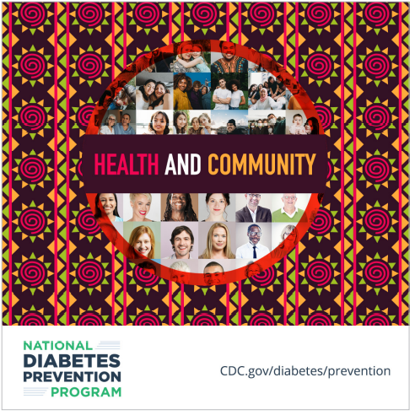  Download Link
Your health journey doesn’t have to be something you do alone. Do it with those you love and sign up for CDC’s group-based National Diabetes Prevention Program lifestyle change program. Learn how you can prevent or delay type 2 diabetes at [insert link to program website]. | 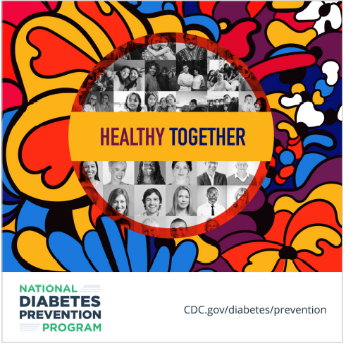  Download Link
Dancing to your favorite music is one way to add physical activity to your life. When you sign up for CDC’s National Diabetes Prevention Program lifestyle change program, you’ll learn more ways to prevent or delay type 2 diabetes. Learn more at [insert link to program website]. | 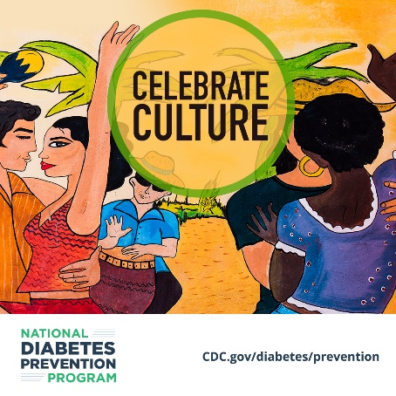  Download Link
Make healthy living a part of your traditions with CDC’s National Diabetes Prevention Program lifestyle change program. It’ll help you prevent or delay type 2 diabetes so you can keep enjoying what matters. [insert link to program website] | 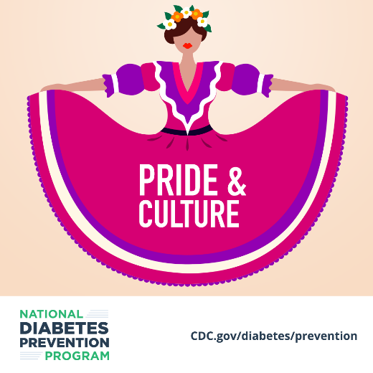  Download Link
What’s your motivation to live healthier? You do so much for your loved ones, and it’s important to take care of yourself for them. With CDC’s National Diabetes Prevention Program lifestyle change program, you can prevent or delay type 2 diabetes. [insert link to program website] | 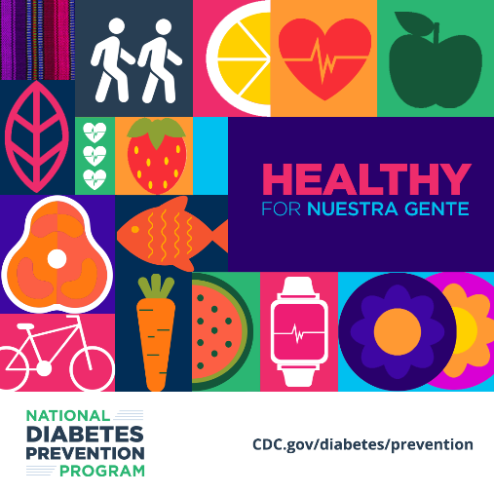  Download Link
You don’t have to give up the foods you love to eat healthy. When you sign up for CDC’s National Diabetes Prevention Program lifestyle change program, you can learn tips like swapping healthier ingredients in favorite recipes. Learn more at [insert link to program website]. | 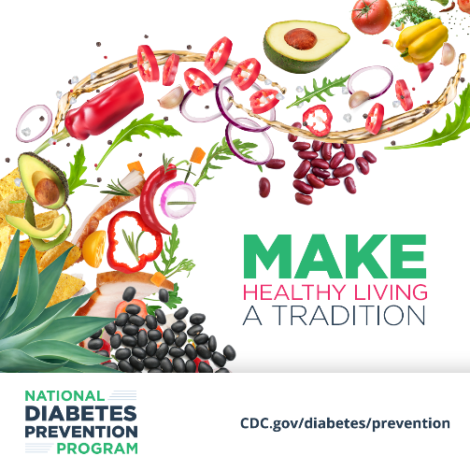  Download Link
Leave a legacy of better health for the next generation. CDC’s National Diabetes Prevention Program lifestyle change program can help you learn to prevent or delay type 2 diabetes. So learn more today! [insert link to program website] | 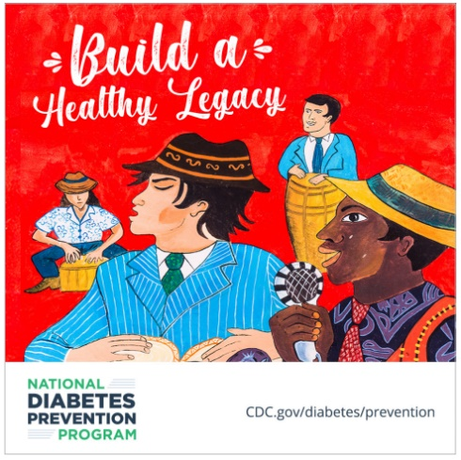  Download Link
Living a healthier lifestyle can be a tradition you pass on. When you sign up for CDC’s National Diabetes Prevention Program lifestyle change program, you can learn ways to prevent or delay type 2 diabetes. Learn more at [insert link to program website]. | 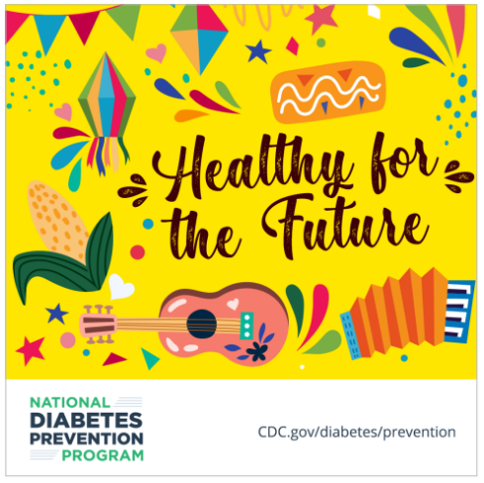  Download Link

Posters
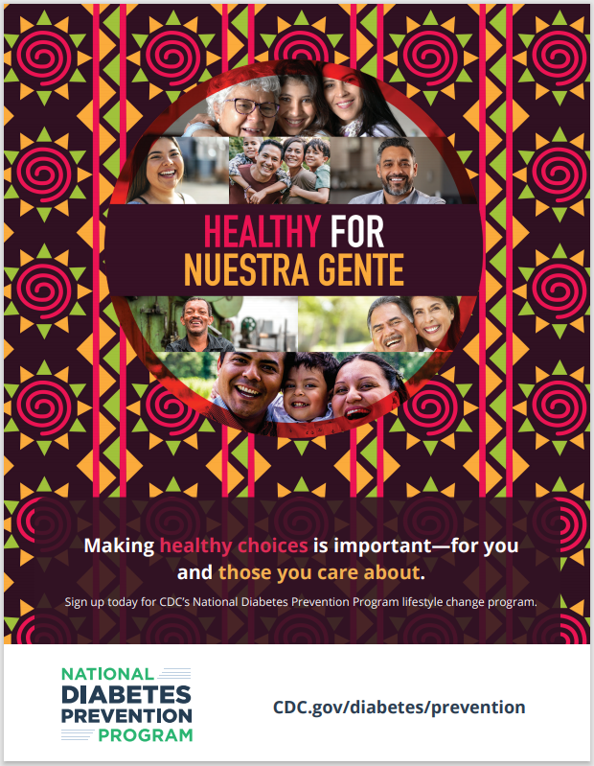
To use: You can print and display these posters during Hispanic Heritage Month to promote the lifestyle change program. Posters are available for download on the 1705 SharePoint site.

