August – End the Summer with Better Health

Drop-In Article

To Use: You can post this article to your organization’s website, publish it in your organization’s newsletter, and/or send it to a local newspaper or magazine. Fill in the yellow highlighted portions with details specific to your lifestyle change program.

Summer May Be Coming to an End, But Healthy Habits Don’t Have To

Summertime and the livin' is easy; with relaxed routines and days filled with fun outdoor activities, vacations, and extra time with friends and family. As the end of summer approaches and families return to more work and school commitments, it’s time to return to healthy routines.

Along with planning carpools and scheduling meetings and after school activities, think about how you’ll build in time for your health. How can you keep the fresh fruit and veggies you enjoyed over the summer part of fall and winter menus? Can you walk while your children or grandchildren participate in sports or band practice? Take this opportunity to plan ahead and set your personal goals to establish some healthy habits before the fall season rolls around.

Creating healthy habits and adding them into your day-to-day life can make a huge positive impact on your health. According to the Centers for Disease Control and Prevention (CDC), 88 million US adults—more than 1 in 3—have prediabetes, a condition where a person’s blood sugar levels are higher than normal, but not high enough yet for a type 2 diabetes diagnosis. Prediabetes puts you at increased risk of developing type 2 diabetes, heart disease, and stroke. If you have prediabetes, you can reduce your risk for developing type 2 diabetes by adopting healthy habits into your daily routine, such as eating meals with more fruits and vegetables, getting regular physical activity, and sleeping enough each night.

[Name of program], part of the CDC-led National Diabetes Prevention Program lifestyle change program, [takes place in name of community and/or virtually] and can help you learn more about how to stick to these healthy habits and reduce your risk of developing type 2 diabetes. In the program, participants work with a trained Lifestyle Coach and other participants to encourage each other along the way.

Making small adjustments in your daily routine can lead to a healthier lifestyle. Here are some helpful tips to get you started as fall approaches and schedules get busier:

- Prepare healthy meals ahead for packed lunches and family dinners. Planning healthy meals ahead of time can save valuable time during the week and help you maintain a well-balanced diet.
- Keep moving and having fun. Just because summer is coming to an end doesn’t mean you can’t enjoy some time outside. Spend some time gardening or going on a walk with your family or friends.
- Make sure you get enough sleep. One in three US adults isn’t getting enough sleep, and over time this can increase the risk for type 2 diabetes, heart disease, weight gain, and depression. Set a bedtime routine by shutting off your phone and laptop for the day and going to sleep at the same time every night.

- Take the 1-minute prediabetes risk test. Once summer comes to an end, it can be difficult to find time for yourself in a busy schedule. But learning about your risk for prediabetes can help you make healthier decisions so you can enjoy more time doing what’s important to you. If you (or someone you love) find out you have prediabetes, learn more about a program like [name of program], [part of the CDC’s National Diabetes Prevention Program OR a CDC-recognized lifestyle change program]. At [name of program], participants can learn ways to lower their chances for getting type 2 diabetes, improve their overall health, and create healthy habits that last a lifetime.

Take some time before the summer ends to understand your risk for type 2 diabetes and learn how you can prevent or delay it by taking steps to change your lifestyle. Creating healthy habits in your life can ensure you live healthier all year long.

E-Newsletter Copy

To Use: The following e-newsletter copy can be used to promote the program in online e-newsletters and email blasts. Consider placements in a community newsletter, local health care provider or network newsletter, and/or faith-based newsletter.
Keep Up the Summer Fun All Year Round With Healthy Habits

Healthy habits are important all year round, but in the summer it's easy to be thrown off track during the long days of fun activities, vacations, and extra leisure time with friends and family. As the end of summer approaches, it’s the perfect time to make some changes for a healthier fall routine.

Take this opportunity to plan ahead and set personal goals to establish some healthy habits before the fall season rolls around. Creating healthy habits and adding them into your day-to-day life can have a huge positive impact on your health. According to the Centers for Disease Control and Prevention (CDC), 88 million US adults—more than 1 in 3—have prediabetes, a condition where a person’s blood sugar levels are higher than normal, but not high enough yet for a type 2 diabetes diagnosis. The good news is prediabetes often can be reversed by losing a modest amount of weight and being more physically active.

[Name of program], part of the CDC-led National Diabetes Prevention Program lifestyle change program, [takes place in name of community and/or virtually] and can help you learn more about how to add these healthy habits into your routine and reduce your risk of developing type 2 diabetes. In the program, participants work with a trained Lifestyle Coach and other participants who can encourage each other along the way.

Making small changes in your daily routine can lead to a healthier lifestyle. Here are some helpful tips to get you started as fall approaches and schedules get busier:

- Prepare healthy meals ahead for packed lunches and family dinners. Planning healthy meals ahead of time can save valuable time during the week and help you maintain a well-balanced diet.
- Keep moving and having fun. Just because summer may be coming to an end doesn’t mean you can’t enjoy some time outside. Spend some time gardening or going on a walk with your family or friends.
- Make sure you get enough sleep. One in three US adults isn’t getting enough sleep, and over time this can increase the risk for type 2 diabetes, heart disease, weight gain, and depression. Set a bedtime routine by shutting off your phone and laptop for the day and going to sleep at the same time every night.

- Take the 1-minute prediabetes risk test. Once summer comes to an end, it can be difficult to find time for yourself in a busy schedule. But learning about your risk for prediabetes can help you make healthier decisions so you can enjoy more time doing what’s important to you. If you (or someone you love) find out you have prediabetes, learn more about a program like [name of program], [part of the CDC’s National Diabetes Prevention Program OR a CDC-recognized lifestyle change program]. At [name of program], participants can learn ways to lower their chances for getting type 2 diabetes.

Take some time before the summer ends to understand your risk for type 2 diabetes and learn how you can prevent or delay it by taking steps to change your lifestyle. Creating healthy habits in your life can ensure you live healthier all year long.

Social Media Images & Post Copy

To use: You can use the following social media post copy and images on Facebook, Instagram, and Twitter. Photos are available for download on the 1815/1817 Box site. Links have been provided below each photo.

Recommended Post Copy | Recommended Image/Graphic
Preparing a nutritious lunch helps kids develop healthy habits early. Discover how to add more veggies and lean protein to your meals when you sign up for CDC’s National Diabetes Prevention Program lifestyle change program. Learn more at [insert link to program website]. | 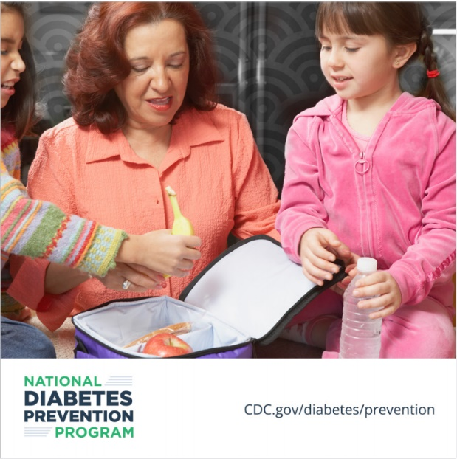  Download Link
The last days of summer offer time to be physically active, which can help prevent or delay type 2 diabetes. Learn ways to add movement to every season when you sign up for CDC’s National Diabetes Prevention Program lifestyle change program. Sign up at [insert link to program website]. | 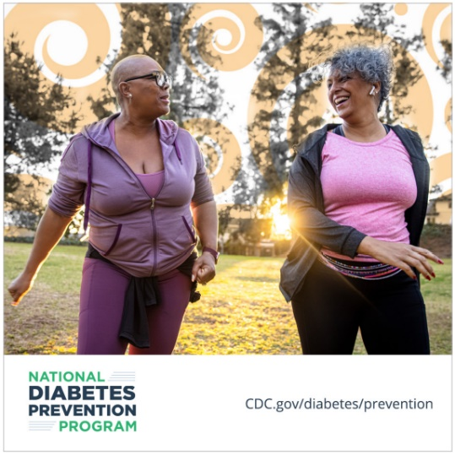  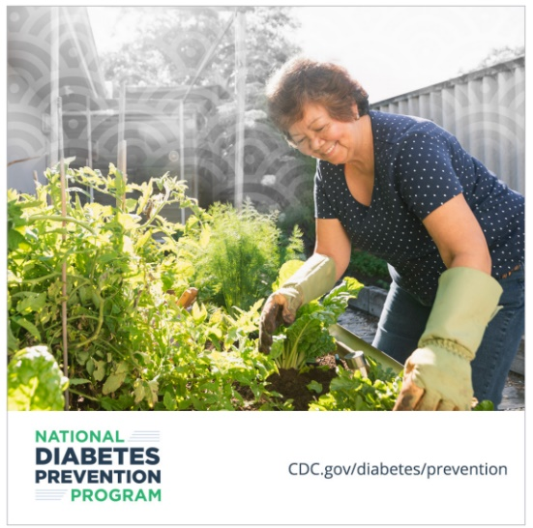  Download Link  Download Link
1 in 3 US adults isn’t getting enough sleep, which can increase the risk for type 2 diabetes. With CDC’s National Diabetes Prevention Program lifestyle change program, you’ll learn tips for getting a good night’s rest. Sign up at [insert link to program website]. | 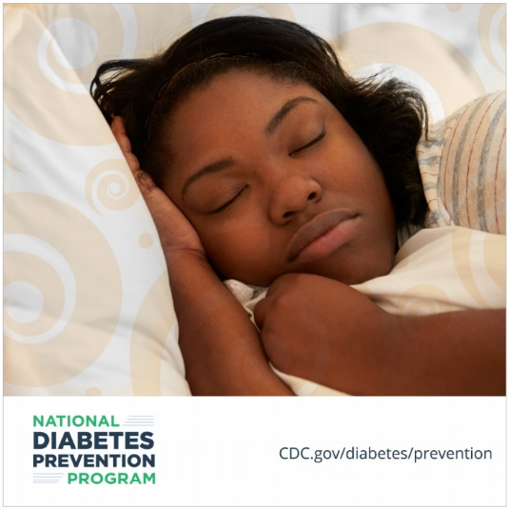  Download Link

